YOLO11 Object Detection - Documentation
This project trains a YOLO11 object detection model for vehicle-part detection. The results documented here are taken from the current local run artifacts in runs/detect/train/, especially results.csv and args.yaml.

What This Model Does
The model predicts bounding boxes for 9 vehicle-part classes:
Class | Annotation count
Fog Lights | 605
Headlights | 1,184
Plate | 456
Rear Window | 123
Side-Mirror | 1,207
Tail Lights | 365
Tire | 2,043
Window | 1,816
Windshield | 957
Total labeled objects across all splits: 8,756.

Project Layout
1. Object Detection/
|-- check_dataset.py
|-- dataset/
| |-- data.yaml
| |-- train/images/ and train/labels/
| |-- valid/images/ and valid/labels/
| `-- test/images/ and test/labels/
|-- predict.py
|-- README.md
|-- runs/detect/
| |-- predict/
| | `-- annotated prediction images
| `-- train/
| |-- args.yaml
| |-- results.csv
| |-- results.png
| |-- confusion_matrix.png
| |-- confusion_matrix_normalized.png
| |-- BoxP_curve.png, BoxR_curve.png, BoxF1_curve.png, BoxPR_curve.png
| |-- train_batch*.jpg and val_batch*_*.jpg
| `-- weights/best.pt and weights/last.pt
|-- train.py
`-- yolo11n.pt
Note: dataset/, runs/, .venv/, and *.pt files are ignored by git in this folder. The documentation references local artifacts that exist on this machine. If this project is shared, export the run artifacts separately.

Dataset Summary
Dataset source metadata in dataset/data.yaml:
Field | Value
Format | YOLO detection, data.yaml plus image/label folders
Roboflow project | objectdetection-7jqlt
Roboflow version | 1
Number of classes | 9
Split quality checks from the current local dataset:
Split | Images | Label files | Objects | Empty labels | Missing labels | Orphan labels
Train | 630 | 630 | 7,667 | 0 | 0 | 0
Valid | 60 | 60 | 737 | 0 | 0 | 0
Test | 30 | 30 | 352 | 0 | 0 | 0
The dataset is structurally clean: every image has a matching label file and no orphan label files were found.

Environment
This folder uses its own Python virtual environment:
cd "1. Object Detection"
.\.venv\Scripts\python.exe -c "import torch; print(torch.cuda.is_available())"
Expected GPU result: True when CUDA-enabled PyTorch is installed. CPU training also works but is slower.

Training Configuration
The current run was launched by train.py and saved to runs/detect/train/. The full resolved configuration is saved in runs/detect/train/args.yaml.
Setting | Value
Task | Detection
Base model | yolo11n.pt
Data file | dataset/data.yaml
Configured epochs | 100
Completed epochs in log | 72
Image size | 640
Batch size | 8
Early stopping patience | 25
Device | 0 GPU
Optimizer | auto
AMP | true
Seed | 0
Output folder | runs/detect/train/
Run training:
cd "1. Object Detection"
.\.venv\Scripts\python.exe train.py
train.py validates the dataset first by calling check_dataset.py. If blocking errors are found, training stops before any GPU time is spent.

Training Results
Primary metric: mAP50-95(B). This is stricter than mAP50 because it averages box quality over multiple IoU thresholds from 0.50 to 0.95.
Metric | Best epoch 47 | Final epoch 72
Precision (B) | 0.8329 | 0.8408
Recall (B) | 0.7587 | 0.7306
mAP50 (B) | 0.8169 | 0.8002
mAP50-95 (B) | 0.6442 | 0.6379
The best checkpoint is:
runs/detect/train/weights/best.pt
Use best.pt for inference unless you specifically need the final checkpoint last.pt. Both checkpoint files are about 5.22 MB.

Result Figures
Training curves:
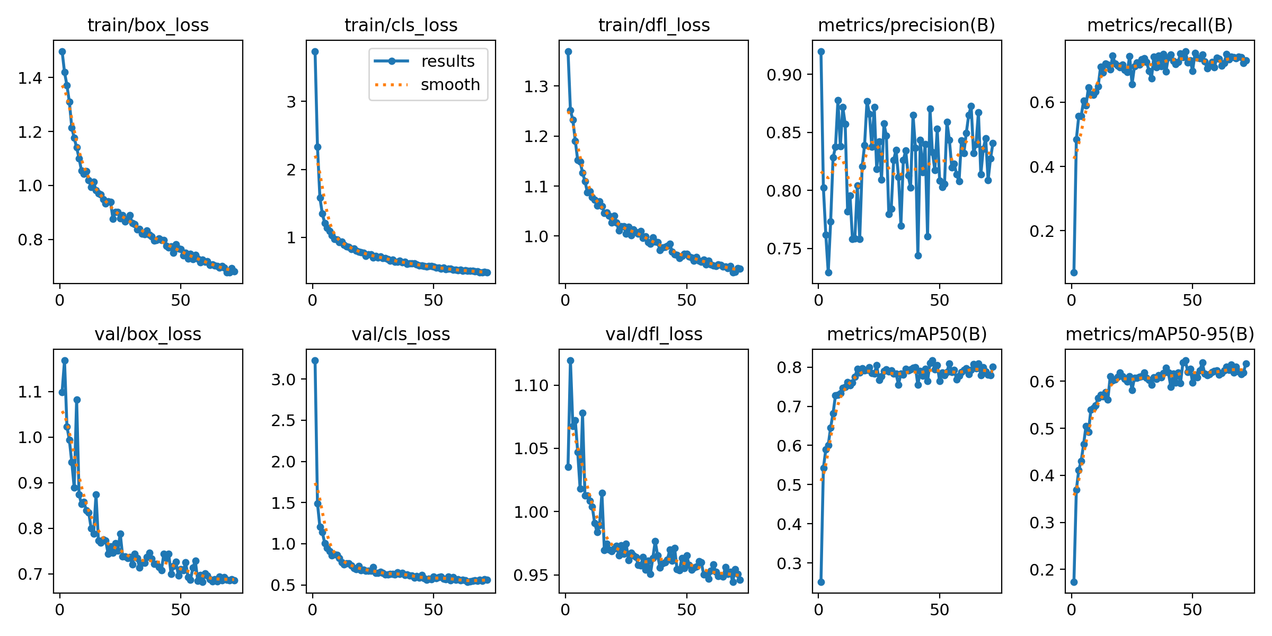
Training results
Confusion matrix:
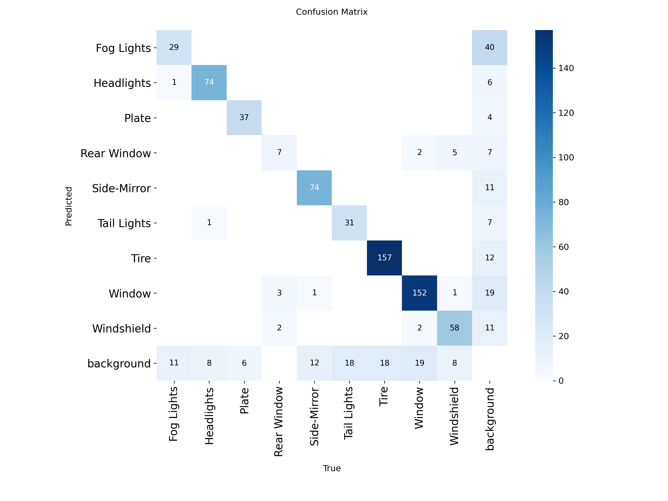
Confusion matrix
Normalized confusion matrix:
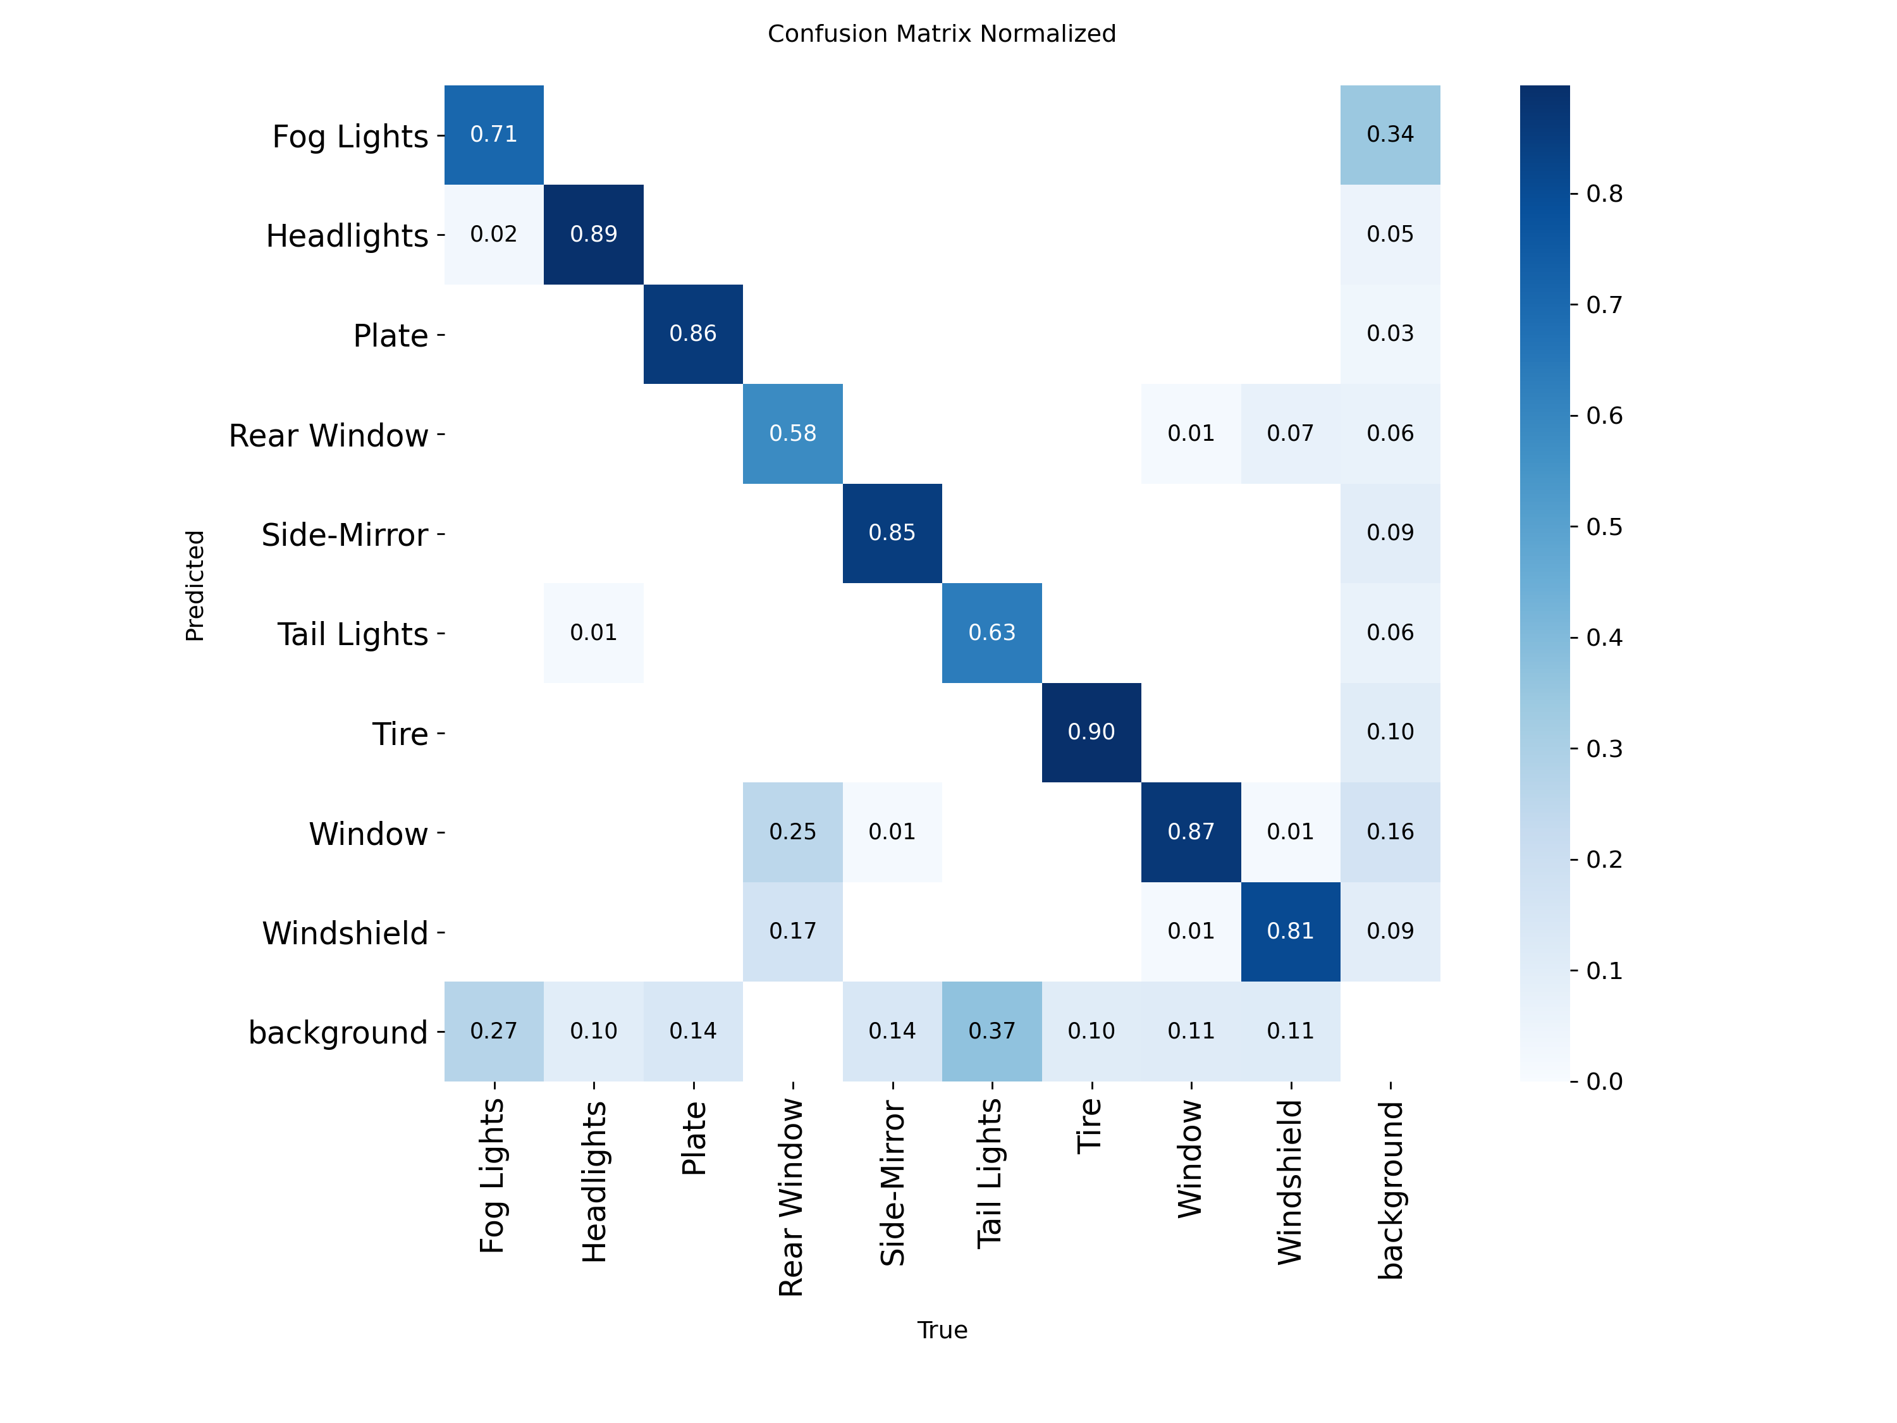
Normalized confusion matrix
Precision-recall curve:
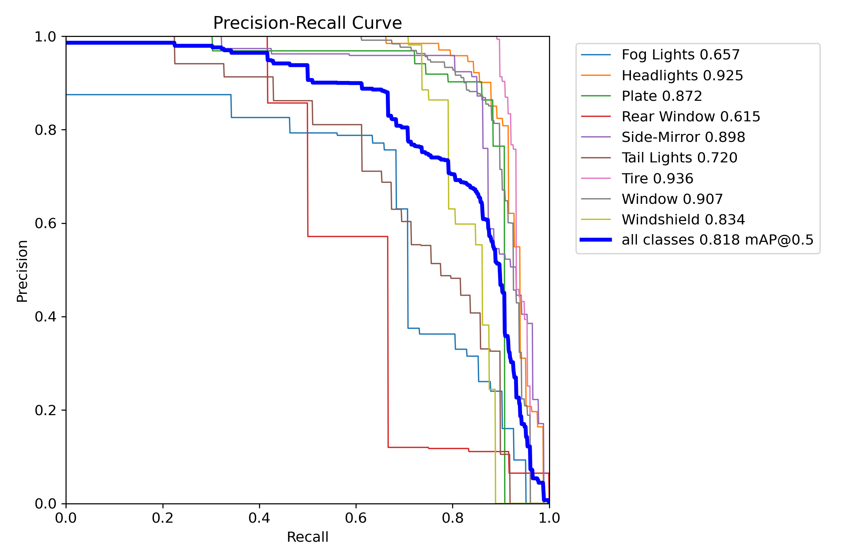
Box precision-recall curve
Additional curves available in the run folder:
File | Meaning
BoxP_curve.png | Precision at confidence thresholds
BoxR_curve.png | Recall at confidence thresholds
BoxF1_curve.png | F1 score at confidence thresholds
BoxPR_curve.png | Precision-recall tradeoff
labels.jpg | Label distribution and bounding-box distribution
train_batch*.jpg | Augmented training batch samples
val_batch*_labels.jpg | Validation images with ground-truth labels
val_batch*_pred.jpg | Validation images with model predictions

Inference
The inference script uses:
Setting | Value
Weights | runs/detect/train/weights/best.pt
Source | dataset/test/images
Confidence threshold | 0.25
Image size | 640
Output folder | runs/detect/predict/
Run prediction:
cd "1. Object Detection"
.\.venv\Scripts\python.exe predict.py
The current local prediction folder contains:
Output | Count | Location
Annotated images | 30 | runs/detect/predict/
Prediction text files | 0 | Not generated by the current predict.py settings
The detection script saves annotated images only. If you need YOLO-format prediction text files, add save_txt=True and save_conf=True to the model.predict(...) call in predict.py.

How To Read The Metrics
Metric | Meaning
Precision | Of the boxes predicted by the model, how many were correct
Recall | Of the real labeled objects, how many the model found
mAP50 | Mean average precision at IoU 0.50
mAP50-95 | Mean average precision averaged across IoU 0.50 to 0.95
Box loss | Bounding-box localization loss; lower is better
Class loss | Classification loss for detected boxes; lower is better
DFL loss | Distribution focal loss used for box quality; lower is better
For this project, mAP50-95(B) is the main score to report. mAP50 is useful for a looser view of object localization performance.

Dataset Validation
Run the checker directly:
cd "1. Object Detection"
.\.venv\Scripts\python.exe check_dataset.py
The checker verifies:
- data.yaml exists and defines class names.
- train, valid, and test splits have matching images/ and labels/ folders.
- Every image has a matching label file.
- Label files have valid YOLO detection rows: class x_center y_center width height.
- Class ids are valid and coordinates are normalized from 0 to 1.
- Every class appears in the annotations.

Troubleshooting
Problem | Fix
CUDA out of memory | Lower BATCH from 8 to 4 or 2 in train.py.
Training is too slow | Use GPU device 0; reduce IMG_SIZE to 512 if acceptable.
Bad or missing predictions | Confirm runs/detect/train/weights/best.pt exists before running predict.py.
Dataset validation fails | Fix the exact file or label path reported by check_dataset.py.
Metrics look high but examples look wrong | Inspect val_batch*_pred.jpg and both confusion matrix files.

Reproducible Workflow
cd "1. Object Detection"
.\.venv\Scripts\python.exe check_dataset.py
.\.venv\Scripts\python.exe train.py
.\.venv\Scripts\python.exe predict.py
Report the model using the best-validation result: mAP50-95(B) = 0.6442 at epoch 47.

